NEWSLETTER

SEPTEMBER 2018

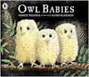This term the children’s activities will be themed around the book

“OWL BABIES”

Art projects will include working with natural resources eg. twigs, leaves, feathers etc. Group work will revolve around story-telling and puppets.

The chosen nursery rhyme for this term is Incy Wincy Spider

Please note that half term is from Monday 23rd October to Friday 27th October 2018.

During this term the children will be celebrating the following events :-

BONFIRE NIGHT – 5th November

DIWALI – 7th November

CHRISTMAS – December

If you child currently attends COG for 5 mornings (15 hrs) but you would like to exchange a couple of mornings for a couple of afternoons, we now have play sessions on Monday, Tuesday and Wednesday afternoons. If your child comes on the minibus and would like them to do a full day, we can now transport them home in the afternoon (only on Mon, Tues & Weds). If you qualify for the 30 hrs free education (subject to available places) we could offer up to 24 hours (8 sessions).



We will soon be holding our Annual Christmas Raffle. As usual there will be a list on the parent’s notice board for items that we will need for the Luxury Food Hamper. We also usually have bottles of booze and a paired up item eg. Bottle of Whisky & Christmas cake, these will also be on the list. If you could donate something please cross the item off the list and put your name alongside. If you would like to donate other items that we could use in the raffle, such as chocolates, toiletries etc. that we can make up into baskets, or you have any baskets we could use for this purpose please bring them in or give them to the escort if your child comes on transport. We usually have the raffle tickets printed in early November. Watch out for the raffle tickets coming home with your child.

Since the last newsletter Chloe Barnes has returned to work, following her maternity leave.

Tazeen who was originally with us as cover for Chloe, has now been given a permanent position.

At Easter Tommy Lee’s left us due to ill health, and Ken Jones joined us to take over Tommy’s driving duties. We have also welcomed back Mike Wilson as a volunteer driver.

Lindsey Allardice has joined us as lunch time assistant and support worker.

We continue to try to improve the outdoor play- areas to enhance the children’s play experiences. Over the summer we had some work carried out to alter our mud kitchen and sand pit areas and we started the process of turning part of the play area into a Sensory Garden. The first phase was to have fencing and a gate installed to make it a more secure area for adult led play.

Egerton Reformed Church £56.001

Bailey Thomas Foundation £5000.002

Weavers Arms (collecting Tin) £64.86

T K MAXX £1500.003

Awards for All £9958.003

Rotary Club £250.00

In memory of Mary Botterill £155.94

Weavers Arms (collecting tin) £50.24

Parent donation £40.00

Mr I A Bham (Abubakar’s dad) £50.00

Justine Baines fundraiser £221.00

1. Wooden inset puzzles
2. Towards purchase of minibus
3. Towards the minibus running costs

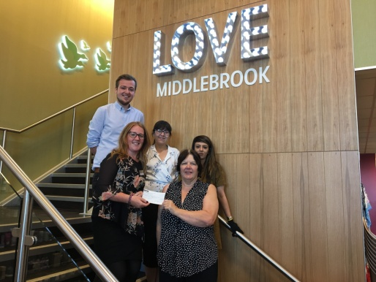

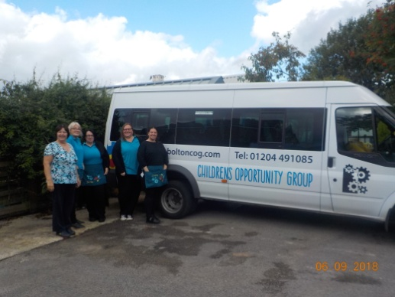

The top picture shows Annette accepting the cheque from staff at T K Maxx. The bottom picture appeared in the Bolton News following our grant from Awards for All

As we all know times are tight when it comes to money. The statutory funding that COG receives, is insufficient to cover all our running costs and in particularly the costs of the minibuses. We have been quite successful this year in raising funds for the minibus service, it costs us approx £15000 each year but we cannot become complacent.

Do you have a local pub or shop who might like to put a collecting tin on the counter?

If you have any fundraising ideas we would love to hear about them.

AND

Did you know that COG is a partner in the Hospice Lottery and also BWFC Goldline & Lifeline Lotteries? This means that should you join either lottery, using one of our dedicated application forms, 45p of every pound you pledge to the Hospice and 70p of every £1 you pledge to BWFC will be donated to COG. Last year our share of the monies paid by our supporters to the Hospice was £225. The minimum payment is £1 per week for the Hospice, £1 per week to the Goldline and £2 per week to the Lifeline, it can be paid by Direct Debit, Cheque or Credit/Debit card. There are big weekly/monthly prizes.

**HOSPICE LOTTERY** – up to £1000 weekly

**GOLDLINE** - £500 every weekday, £100s in consolation prizes and up to £5000 in the Goldline extra draw.

**LIFELINE** - £2000 weekly, 10 x £50 consolation prizes and up to £7500 in the Rollover draw.

For more information and an Application form/s for either or all lotteries please speak to Annette in the office